Student Name: Gideon Ewa
DATA TRANSFORMATION SCREENSHOTS
For the three datasets, the data was pre-processed by changing data types, renaming fields and adding some calculated columns. The screen shots are as shown below:
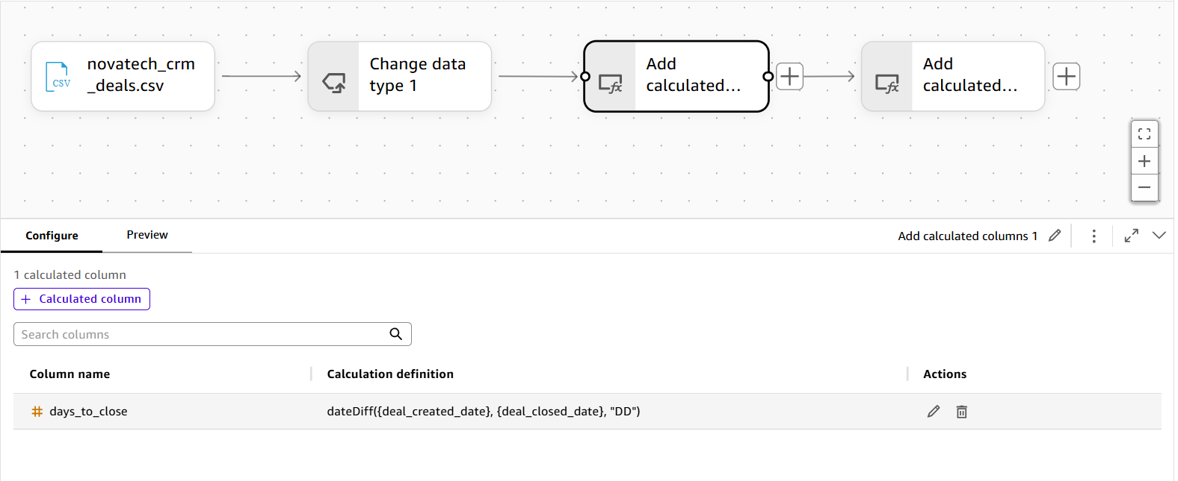

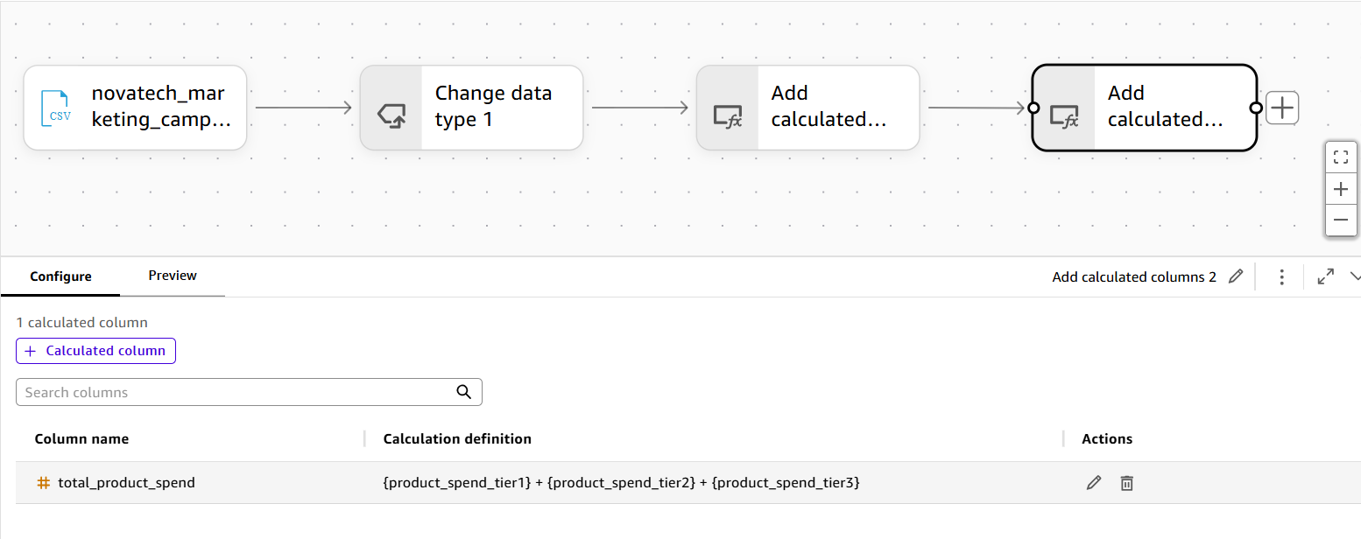

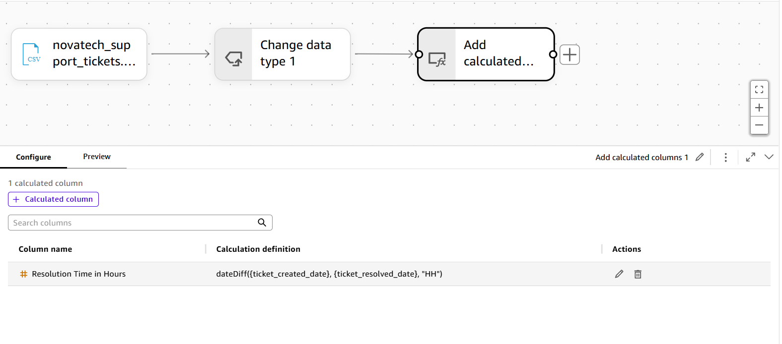

Unified Dataset
This was achieved by combining the three transformed datasets into a single unified table as shown in the screenshot below
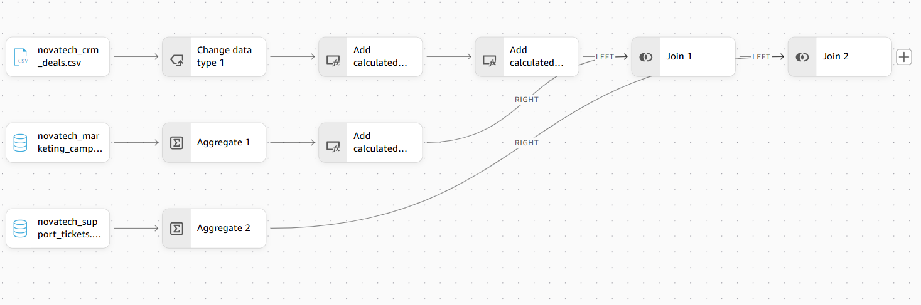
Join Strategy for Unifying the CRM, Marketing, and Support Datasets
The goal was to produce a single, account-level dataset that could support cross-functional analysis. Achieving this required combining three datasets together: CRM, Marketing, and Support.
Anchor table
Novatech_crm_deals.csv was selected as the anchor table for the join. The reasoning was that CRM is the only one of the three datasets that carries genuine account/company attributes.

The join key
All three datasets share account_id, making it a sensible choice for a join key.

Join type: left joins
CRM was left-joined to Marketing, and that result was left-joined to Support. Left joins preserve every CRM record regardless of whether matching Marketing or Support data exists.
The problem that emerged: row multiplication
A direct three-way join on account_id, attempted at first without further preparation, produced a serious side effect of row multiplication. Because Marketing has multiple rows per account and Support also has multiple rows per account.
This was fixed by Aggregating the Marketing and support table before joining them to the CRM table.

Four Datasets uploaded to spice
